# CS 255 System Design Document Template

## UML Diagrams

### UML Activity Diagrams

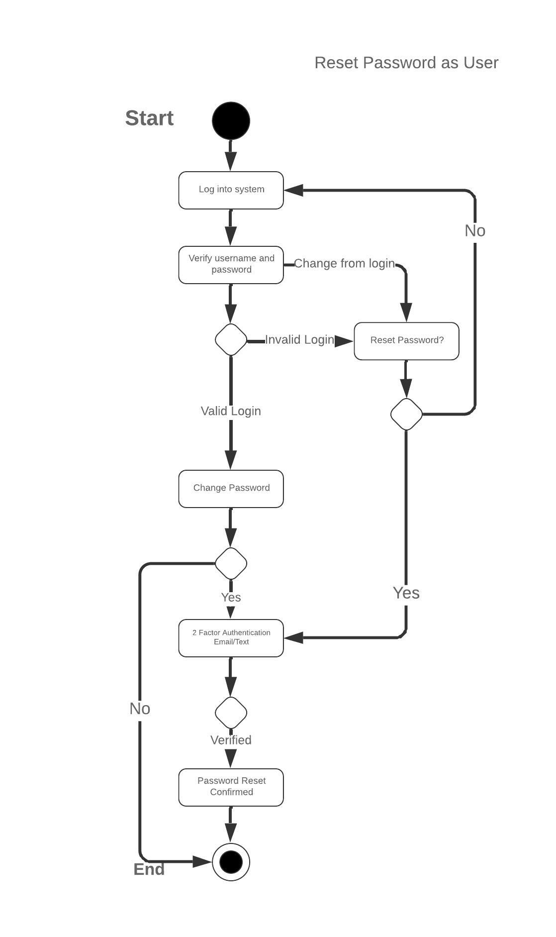

### UML Sequence Diagram

### 

### UML Class Diagram

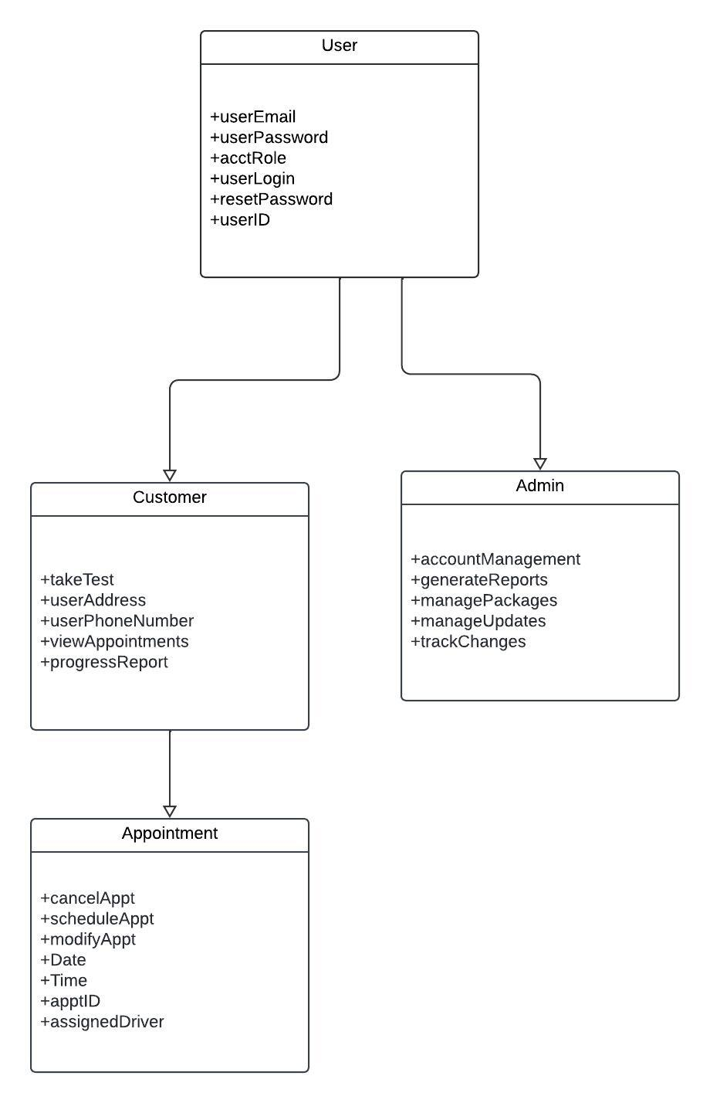

## Technical Requirements

Several changes must be implemented for the DriverPass software to function as predicted. For the application to perform as the client expects, the use of cloud architecture would be ideal. Cloud-based architecture would allow data access from anywhere and mitigate the upfront cost of hosting a server and storage on-site. A browser-based web app would allow for multiple operating systems and fewer OS-specific requirements. This would accommodate the use of mobile devices as well.

The only hardware requirement is a computer and someone knowledgeable to use it, due to the use of a cloud-based web app. The software would be based on the cloud service preferred as well as the programming language used. Personally, I would use Microsoft Azure for cloud services, React for the front end, and Node.js for the back end. The infrastructure needed would be dynamically scaled from the cloud provider.